Name: Korey Rodi
Here are some basic rules for calculating the Big O for some T(n) or an algorithm.
- Only the highest degree of n matters. For example
T(n) = n³ + 5n² + 10⁷ → O(n³)
since once n becomes super-massively huge, the other terms just stop mattering.
- Constant factors don’t matter. T(n) = 500n and T(n) = 0.005n both O(n). Again, as n becomes bigger, these constants stop mattering; what matters is the rate of growth. Example:
T(n) = 50n³ − 2n² + 400 → O(n³)
- Counting the number of nested loops usually works.
Demo this assignment to the Professor or TA.
0 points
For each of the following T(n), write the corresponding Big O time complexity. Some series may require research.
- (2 points) T(n) = n² + 3n + 2
O (n^2)
1.
- (2 points)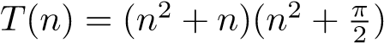
O (n^4)
2.
- (2 points) T(n) = 1 + 2 + 3 + ... + n − 1 + n
O (n^2)
3.
- (2 points) T(n) = 1² + 2² + 3² + ... + (n − 1)² + n²
O (n^3)
4.
- (2 points) T(n) = 10
O (1)
5.
- (2 points) T(n) = 10¹⁰⁰
O (1)
6.
- (2 points) T(n) = n + logn
O (n)
7.
- (2 points)
O (n)
8.
- (2 points) T(n) = (n + 1) · log(n) − n
O (n log n)
9. 10. (2 points)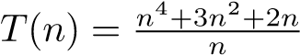
O(n^3)
10.
20 points
- (4 points) What is the time complexity to get an item from a specific index in an ArrayList?
It is O (1)
- (3 points) What is the time complexity remove an item in the middle of an ArrayList?
It is O (n)
- (3 points) Why?
Getting an item from an array List means a constant time of going through the list and returning the item that means that regardless of the size it is always the same run time.
Removing an item from the middle of an array List is O (n) because there is a for loop used to shift all the indexes over one after one is removed
- (3 points) What is the average time complexity to add an item to the end of an Array List?
It is O (1)
- (3 points) What is the worst case time complexity to add an item to the end of an Array List? What if you have to or don’t have to reallocate?
The worst case is that you have to reallocate the list to another which bumps it up to O (n) if the list is already of proper size or there is space it remains O (1)
- (4 points) Taking this all into account, what situations would an Array List be the appropriate data structure for storing your data?
When you have a moderate sized data that does not need to be resized often and just needs to be accessed and modified. This is because the action of reallocating the list can take a while and is not the most ideal as the data grows bigger.
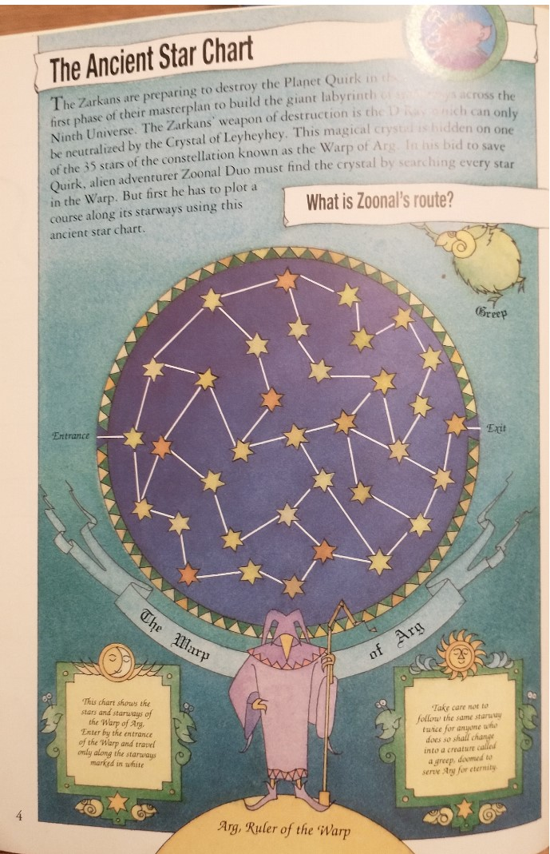
Figure 1: Please look at the above puzzle, taken from Sarah Dixon’s Map & Maze Puzzles and answer the questions on the next page.
0 points
- (10 points) The attached puzzle, while from a children’s puzzle book, is actually a very interesting graph theory problem, known as the Rudrata Path or Hamiltonian Path. What is the Rudrata Path problem and how does it correspond to the above puzzle?
A Hamiltonian path is a problem where on a graph there are lots of vertex, and it states that you must visit each vertex one time and one time only. This applies to the problem above because the goal of that puzzle is to visit every star and check if the wizard has found the magic crystal. Once doing so he has to exit the puzzle, so it is all about planning a proper path to visit the stars in a specific order.
- (10 points) Suppose we generalized the above puzzle so that there was any number of stars, rather than just 35. Let the number of stars in the above puzzle be defined as n. If there are n stars and there are starways between any number of random pairs of stars such that a solution exists, how many paths would an algorithm need to check in order to check to find the solution?
n – 1! With a run time of O(n!)

bogosort attempts to sort a list by shuffling the items in the list. If the list is unsorted after shuffling, we continue shuffling the list and checking until it is finally sorted.
- (5 points) What is the worst case run time for bogosort?
Infinite time or unbounded
- (5 points) Why?
Since the list is randomly shuffled the worst-case scenario is that the list is never sorted and keeps running for ever

- (5 points) What is the average case run time for bogosort (Hint: think about a deck of cards )?
O (n! * n)
- (5 points) Why?
This is the run time for the bogosort because there is n permutations of the elements and then for each permutation you need to check for the length of the list if it is in order.

- (20 points) For each of the methods you wrote in Lab 2, figure out the time complexity of the method you wrote. To turn in this portion, attach a printout of the code and specify the time complexity of each.
public static <E> boolean uniqueness(List<E> list){
for(int i = 0; i < list.size();i++) {
O (n^2)
E firstItem = list.get(i);
for(int k = i + 1; k < list.size(); k++)
if(firstItem.equals(list.get(k))){
return false;
}

}
return true;
}
public static List<Integer> allMultiples(List<Integer> list, int i){
O (n)
List<Integer> newList = new ArrayList<>();
for(int j = 0; j < list.size(); j++){
if(list.get(j) % i == 0){
newList.add(list.get(j));
}
}
return newList;
}
public static List<String> allStrings(List<String> list, int i){
List<String> newList = new ArrayList<>();
O (n)
for(int j = 0; j < list.size(); j++){
String word = list.get(j);
if(word.length() > i) {
newList.add(list.get(j));
}
}
return newList;
}
public static <E extends Comparable <E>> boolean isPermutation(List<E> list, List<E> list2){
if(list.size() != list2.size()){
return false;
O (n log n)
}
Collections.sort(list)
Collections.sort(list2);
for(int i = 0; i < list.size(); i++){
E item = list.get(i);
E item2 = list2.get(i);
if(!item.equals(item2)){
return false;
}
} return true;
}
public static List<String> stringToListOfWords(String word){
String regex = "\\s+";
O (n)
List <String> newList = new ArrayList<>();
String[] newAdds = word.split(regex);
for(int j = 0; j < newAdds.length; j++){
newList.add(newAdds[j]);
}

return newList;
}
public static <E> void removeAllInstances(List<E> list, int i){
for(int j = 0; j < list.size(); j++){
O (n^2)
while(list.get(j).equals(i)){
list.remove(j);
}
}

}

